Male urethra

Extension
From neck of the bladder to external urethral meatus

Measurements
Total length in males: 18 to 20 cm
Literature documenting the length of the normal male adult urethra is scarce.
Ref: Tobias. S. Kohler, Mitchell Yadven, Ankur Manvar, Nathan Liu, Manoj Monga. The length of the male urethra. Int. braz j urol, 2008, 34 (4):451-456

Three parts
- Prostatic urethra
- Membranous urethra
- Penile (or spongy) urethra
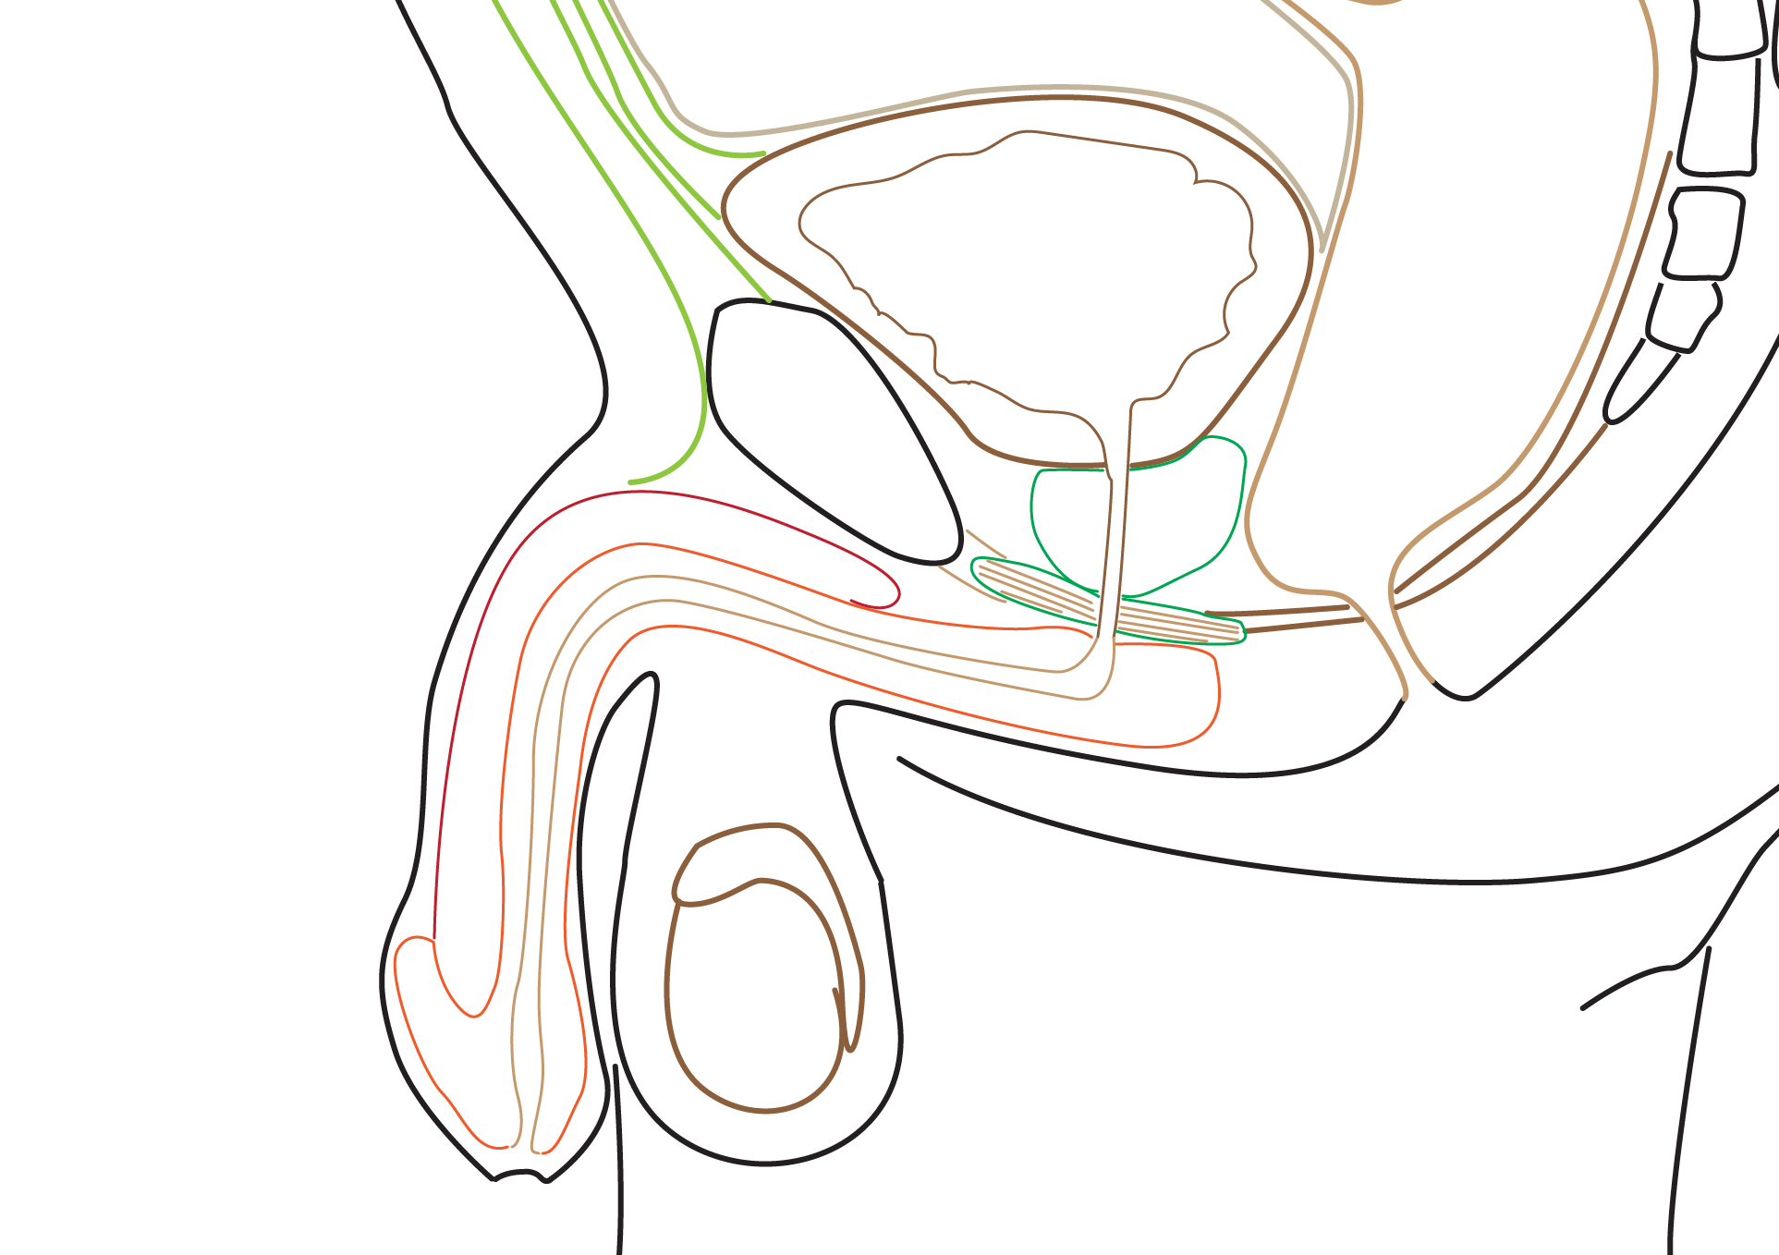

Prostatic urethra
Extension: from neck of trigone of bladder to urogenital membrane

Measurements
Measures about 2.5 to 3 cm
Prostatic urethra is the widest and most dilatable part of male urethra

Relation to prostate
Descends in anterior part of prostate
The gland in relation to urethra is referred as transition zone
At the mid-point, prostatic urethra forms 45 degree within the stubstance of prostate gland
Segment proximal to this is surrounded by the internal urethral sphincter
This segment is compressed in benign prostatic hyperplasia

Features of prostatic urethra
5 important features

Urethral crest
- A long mucosal fold in the posterior wall of prostatic urethra
- Formed by insertion of trigone of bladder

Verumontanum (colliculus seminalis)
- An elevation in the middle of urethra crest
- Prostatic utricle opens here
- At the same level - ejaculatory ducts opens in the urethra crest

Prostatic utricle (or uterus masculinus, vaginus musculinus)
- Blind pouch in the verumontanum
- Develops from united caudal ends of paramesonephric duct
- Corresponds to uterus and upper part of vagina in males

Orifices of the ejaculatory ducts
- Open at the level of prostatic utricle in the urethral crest
- Prostatic sinus
- Gutters on the side of urethral crest
- Each sinus receives 15 - 20 prostatic glands and ejaculatory duct
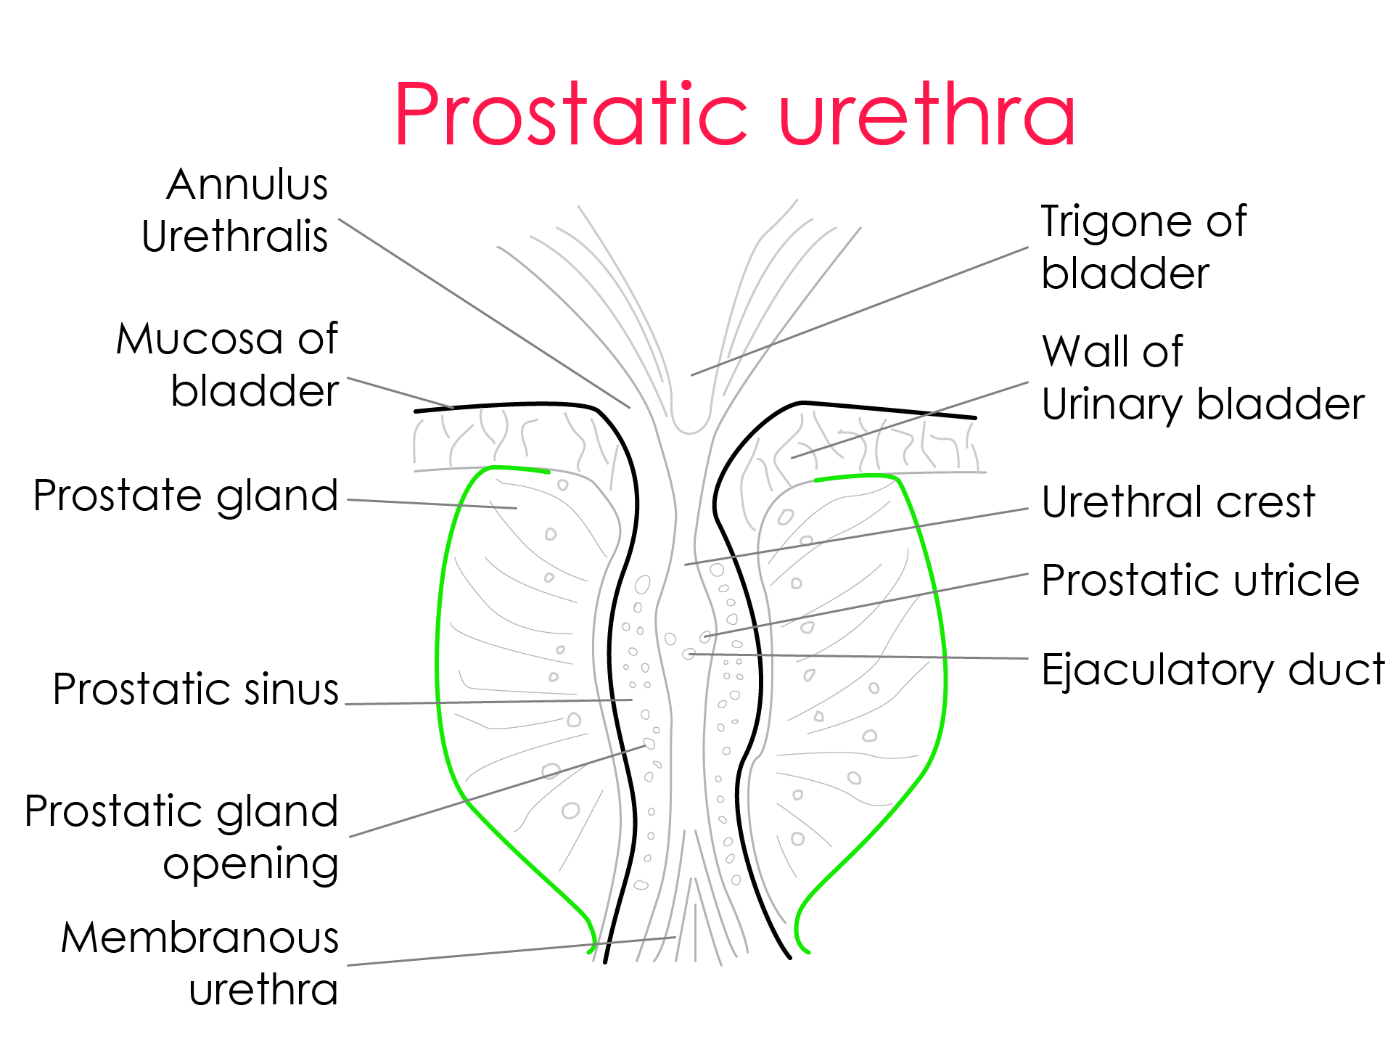

Membranous urethra
Part of the urethra present within the urogenital diaphragm
Surrounded by the deep transverse perinei muscles - acts as sphincter urethrae (external urethral sphincter)
Lumen is star shaped

Measurements
Membranous urethra is the narrowest and least dilatable part of male urethra
Length - 2 cm

Important relations
On either side - membranous urethra is related to bulborethral glands (Cowper's glands) in males
Bulbourethral glands and their ducts have different course in males and females
In males - ducts pierces perineal membrane separately and enter into the penile urethra
In females - Bartholin's glands (bulbourethral glands, greater vestibular glands) are located in the superficial perineal pouch

Spongy urethra
From the perineal membrane to external urethral meatus
Length - 15 cm
S shaped
In the superficial perineal space - it pierces the corpora spongiosum
Runs in the penis upto the tip

Dilatations

Bulbar urethra
- Enlarged part of urethra, just ditsal to perineal membrane
- Also called intrabulbar fossa
- Invested in the bulb of the penis
- Normally urethra bends acutely at this location
- Trapezoid shape in cut-section
- Ducts of bulbourethral glands (Cowper's glands) opens into balbar urethra

Navicular fossa
- A small dilation of the urethra just proximal to the urethral meatus

Urethral glands
Littre's glands
Small tubular glands
Open into the urethral lacunae (a small pit - like mucosal recesses throughout spongy urethra

External urethral meatus
A narrow sagittal slit in the tip of navicular fossa
Present in the glans penis
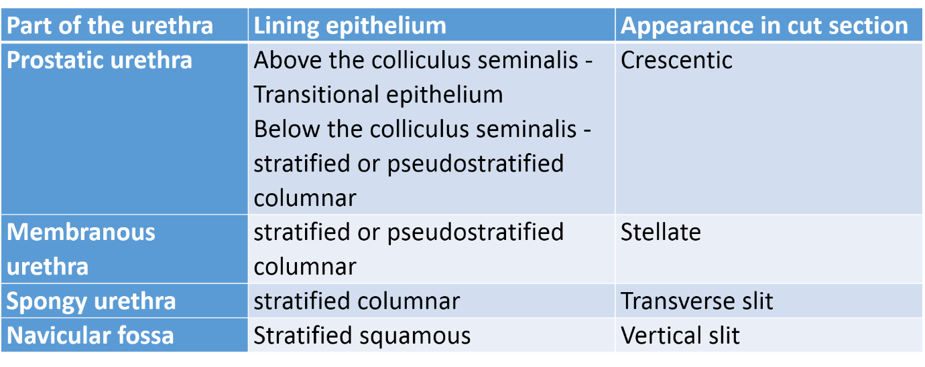

Urethral sphincters

Urethral sphincters - Composition and innervation

Internal urethral sphincter
- Located at the inferior end of the bladder
- Continuous with detrussor muscle
- Muscle fibers form a horseshoe-like arrangement that is continuous with the smooth muscle fibers of the bladder
- Involuntary (sympathetic nerves - T11 to L2)
- Smooth muscles
- Relaxes during urination
- Under sympathetic influence, during ejaculation - it closes and prevents retrograde ejaculation

External urethral sphincter
- Secondary sphincter to control the flow of urine
- In males - External sphincter muscle (arising from inferior rami of the pubis and ischium) + fascia of the pelvic diaphragm
- In females - Sphincter urethrae + compressor urethral muscle + urethrovaginal sphincter
- located at the distal inferior end of the bladder in females and at the level of the membranous urethra in males
- Skeletal muscles
- Voluntary (somatic nerves - S2, 3, and S4 segments)

Function of urethral sphincters
Control micturition
Voluntary relaxation of external sphincter = leads to voiding
Parasympathetic impulses = contractions of the bladder and relaxation of the internal sphincter

Urinary incontinence
Involuntary urination
Most commonly due to urinary sphincter incompetence
Three main subtypes
- Urge incontinence
- Stress incontinence
- Mixed incontinence

Blood supply

Arterial supply
Prostatic urethra - inferior vesical artery, middle rectal artery
Membranous urethra - artery of bulb of penis
Penile urethra - urethral artery, bulbar artery and branches from deep and dorsal artery of penis

Venous drainage
Drain into the prostatic plexus through deep dorsal vein

Lymphatics
Drain into internal and external iliac nodes

Innervation
Through prostatic plexus
Penile part is innervated by pudendal nerve

Urinary catheterization - anatomical considerations
Insertion of catheter through urethra into the urinary bladder to drain the urine
Holding penis perpendicular to the body reduces the curves in the urethra while catheterization
Asking the patient to bear down as if passing urine - shall make the external sphincter to relax and easier entry of the catheter
Applying pressure in the perineum, guides the catheter to enter the urogenital diaphragm.
Ones tha urine dribbles from the Y shaped end of the catheter, the baloon is inflated

Rupture of urethra
Most common rupture of urethra - bulbar urethra
Urine collects in superficial perineal pouch in scrotum, penis and anterior abdominal wall
Extension of urine into the anal triangle is prevented by attachment of Colle's fascia to the posterior margin of urogenital diaphragm
Urethral rupture above the urogenital diaphragm leads to collection of in the urine around the prostate, urinary bladder and in extraperitoneal space

Due to peculiar fascial attachment, extravazation of the urine differs between anterior and posterior urethral rupture

Rupture of urethra above the perineal membrane
  - Rupture of prostatic and membranous segments
  - Urine and blood collects in extraperitoneal part of pelvis
  - Pelvic fractures are responsible for 90% of these injuries

Rupture of urethra below the perineal membrane
  - Rupture of penile urethra
  - If the perineal fascia of Gallaudet and the penile fascia of Buck – intact
  - Then the extravasation is limited to penile shaft

If the perineal fascia is injured
    - The extravasated urine reaches superficial perineal space, periscrotal and peripenile spaces, and upward upon the abdominal wall
    - As the posterior margin of the perineal membrane is firmly attached, extravasated urine never reaches the anal triangle
    - As the fascia scarpa (membranous layer of the superficial abdominal fascia) is firmly attached to the fascia lata (deep fascia of the thigh) along the inguinal ligament (Holden’s line) extravasated urine in anterior rupture of the urethra do not reach the thigh

